Practical Test

Students have 50 minutes to complete this test

No talking allowed

Use any appropriate software and address all the questions and requirements, complete as many sections as possible.

1. Create a folder titled EXAM8 in your Student Folder
(save 3 Graphics) saved as requested… 50 marks
(xxx = your surname)
Graphic Skills
Copy the Elephant picture included.
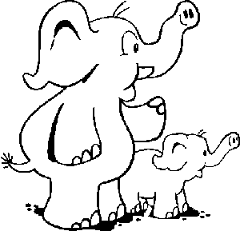

Save this file as XXXELE1, replacing XXX with your surname. Add the appropriate extension

Now make the following changes to image:

- Colour the small elephant pink
- Colour the large elephant green
- Colour all their toenails red
- Make the large elephants tusk blue
20 marks

Save a copy of your graphic
Save this file as XXXELE2, replacing XXX with your surname. Add the appropriate extension

Next

- Add blue spots all over the small elephant
10 marks

Save a copy of your graphic
Save this file as XXXELE3, replacing XXX with your surname. Add the appropriate extension

Next

- Add another small elephant exactly the same as the existing one on the left side of the large elephant.
- Remove the trunk from the original small elephant.

20 marks

